BT6270| BE22B048

Report: Assignment 1
Hodgkin Huxley Neuron Model

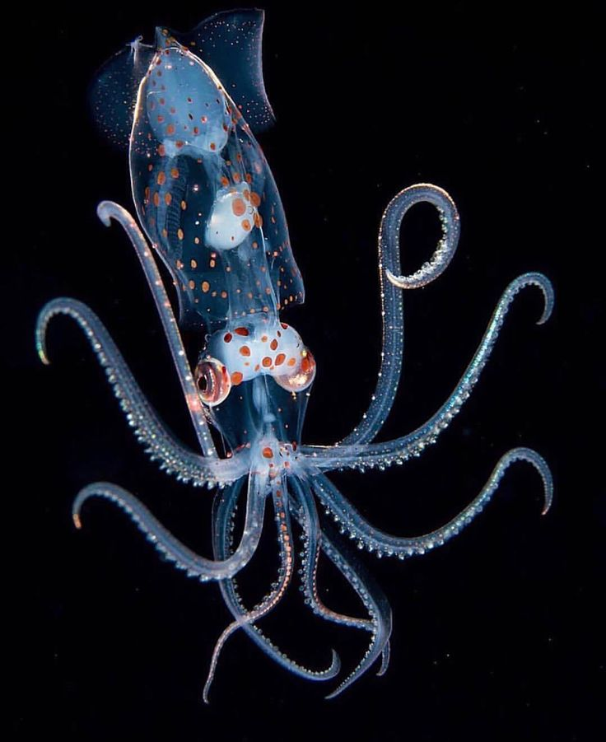

Files In the Zip Folder
- Problem Statement, BT6270_Assignment-1.docx.
- IPython notebook, be22b048_as1_HH_dynamics.ipynb: contains the complete code for the model and different simulation conditions.
- CSV file, hh_firing_behavior_I0_I160_sweep: A CSV file that contains the number of action potentials and firing rate of the model for different constant input currents.

Analysis of Hodgkin-Huxley Neuron Dynamics
This report details the simulation of a Hodgkin-Huxley (HH) neuron model to explore its firing patterns in response to varying levels of constant applied current.
The analysis involves two main stages:
- A classification of the model dynamics viz., no Action Potentials (APs), finite APs, continuous APs and AP distortion across a wide range of currents
- A detailed examination of representative examples from each identified regime.

Model Parameters
I used the Hodgkin-Huxley model, with parameter values derived from their Nobel Prize-winning experiments on the giant squid axon.
The key parameters are:
- Maximal Conductances:
  - gNamax​​: 120.0 mS/cm² (Sodium)
  - gKmax​​: 36.0 mS/cm² (Potassium)
  - gl​: 0.3 mS/cm² (Leak)
- Reversal Potentials:
  - ENa​: 50 mV (Sodium)
  - EK​: -77 mV (Potassium)
  - El​: -54.387 mV (Leak)
- Membrane Capacitance:
  - Cm​: 1.0 µF/cm²
Choosing these values accurately reproduces the experimentally observed shape and propagation of an AP.

Simulation and Analysis Assumptions
I made the following assumptions to facilitate the analysis:
- Numerical Integration: The model's differential equations were solved using the Forward Euler method. with a time step (dt) of 0.01 ms. The step size is a compromise between numerical stability and computational cost.
- Simulation Duration: A total simulation time (T) of 0.5 second (500 ms) was used for the current sweep. This duration is long enough to accurately calculate the steady-state firing rate and to observe whether the neuron's firing adapts or ceases over time.
- Initial Conditions: The simulation starts from the resting state of the neuron (v=−65 mV), with the gating variables (m,h,n) set to their corresponding steady-state values at rest. This ensures that the neuron's response is due to the applied stimulus and not a transient effect of arbitrary initial conditions.

Classification of Firing Patterns
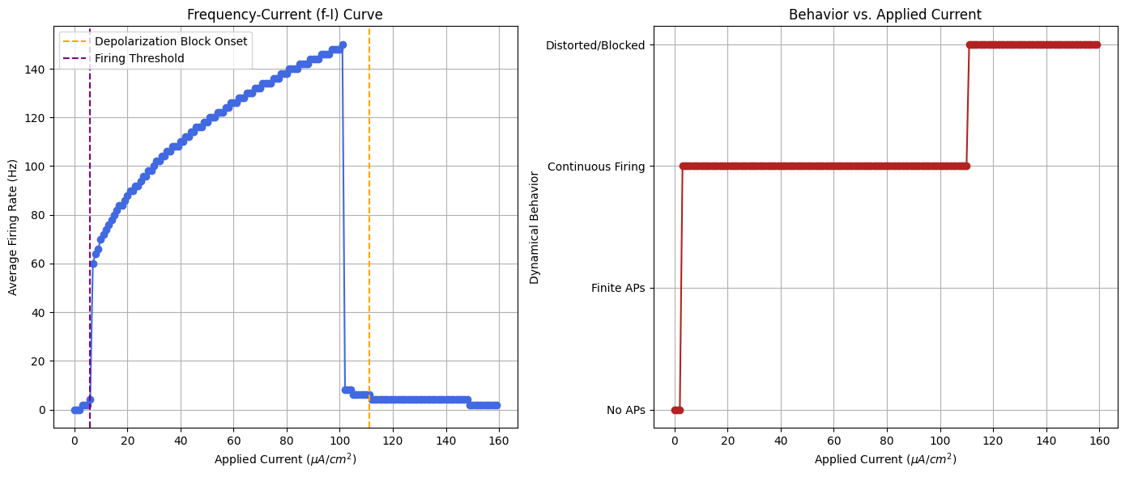

Below, I describe the tools and logic used to classify the voltage trace into the different regimes.
Imported Functions:
- scipy.signal.find_peaks: This function was used to detect action potentials (APs) as It identifies local maxima in the voltage trace.
- numpy.mean: Used to calculate the average membrane potential during the final phase of the simulation, which I compared with a threshold for detecting depolarization block.

Classification Logic and Assumptions:

Dynamic Classification Via analyze_voltage_trace_app1
The resulting voltage trace for each in put current value was passed to the analyze_voltage_trace_app1 to classify the fring based on it’s features.
Imported Functions:
  - scipy.signal.find_peaks: Used to detect action potentials (APs) by identifying local maxima in the voltage trace.
  - numpy.mean: Used to calculate the average membrane potential during the final phase of the simulation.
Dynamic Classification Logic
- Spike Detection: An AP was counted if its peak potential exceeded -20 mV, as specified by the height=-20 argument in find_peaks.
- Depolarization Block Check: The neuron was classified as "Distorted/Blocked" if the mean voltage in the last 20% of the simulation was greater than -40 mV. This condition takes precedence and identifies the blocked state regardless of initial spike activity.
- Finite vs. Continuous Firing: If not blocked, the behavior was determined by the timing of the last spike. If it occurred before 80% of the simulation time had elapsed, the regime was "Finite APs"; otherwise, it was "Continuous Firing."
Current Ranges for Dynamical Regimes
Behaviour | Range of Applied Current I_{app}​ (µA/cm²)
No Action Potentials | ~0 - 5
Finite APs | ~7 - 9
Continuos Firing | ~ 10 - 113
Depolarisation Block | ~ Greater than 113

Step 2: Hardcoding Current Values For Classification Via analyze_voltage_trace_app1
I observed that the frequency of firing (along with other properties) monotonically increased or decreased in a given regime. Thus, after the Dynamic Classification was complete, and the initial "Behavior vs. Applied Current” and “Firing Rate vs Applied currrent ” plot was generated, specific hardcoded current values were chosen to serve as clear boundaries to separate the regimes. I mostly used visual inspection of voltage vs time plots to determine the exact boundary values.

Selection of Iapp and Plotting for Each Regime
After the complete classification process, values belonging to each regime were chosen to serve as a representative example.
The selected representative currents in the notebook are:
- I_{no_ap}​ = 3.0 µA/cm²
- I_{finite_aps}​ = 7.0 µA/cm²
- I_{continuous}​ = 60.0 µA/cm²
- I_{distorted}​ = 140.0 µA/cm².

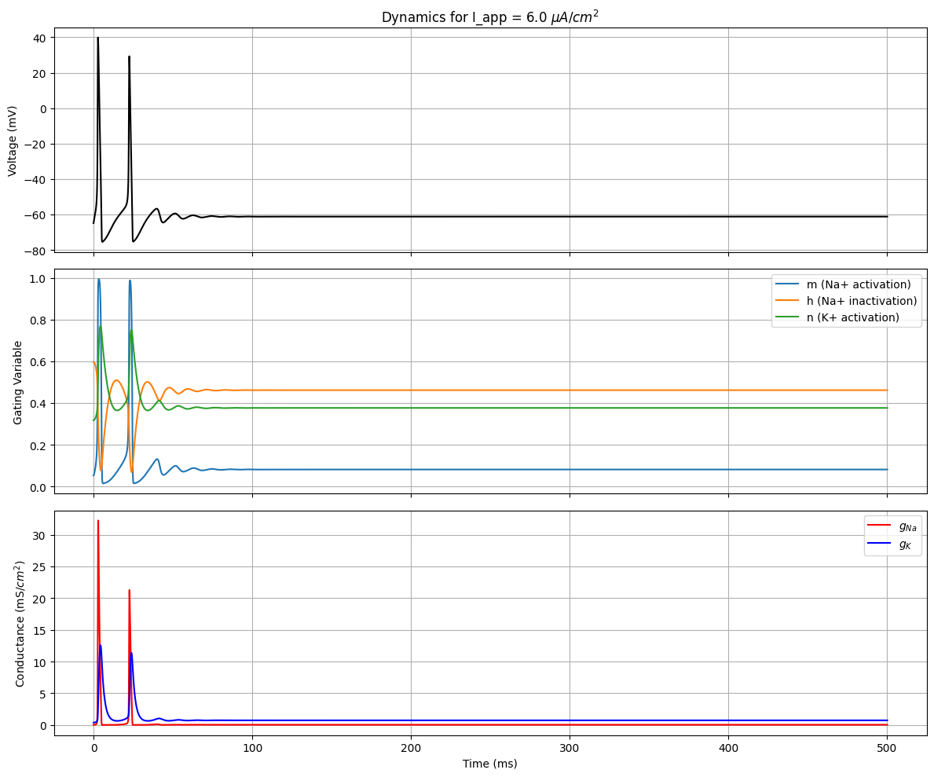

Case 1: No Action Potentials
Observation: The current causes a subthreshold depolarization insufficient to trigger a spike. The voltage-gated sodium channels do not activate sufficiently
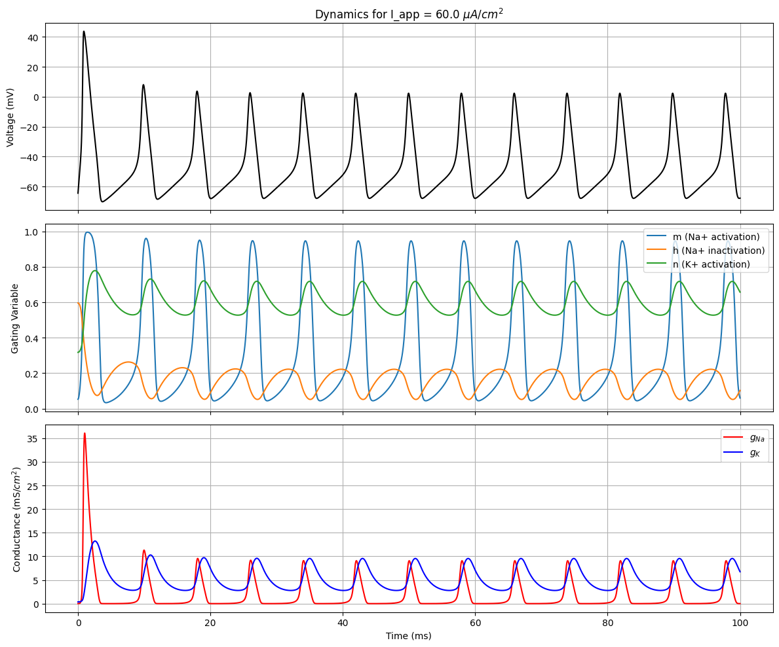

Case 2: Finite Action Potentials
Observation: The neuron fires a short burst and then stops, a behavior known as adaptation. This is driven by the slow accumulation of the potassium current (IK​), which eventually becomes strong enough to prevent the membrane from reaching threshold again.



Case 3: Continuous Firing
- Observation: The current reliably overcomes the potassium current, leading to a rhythmic, continuous train of action potentials
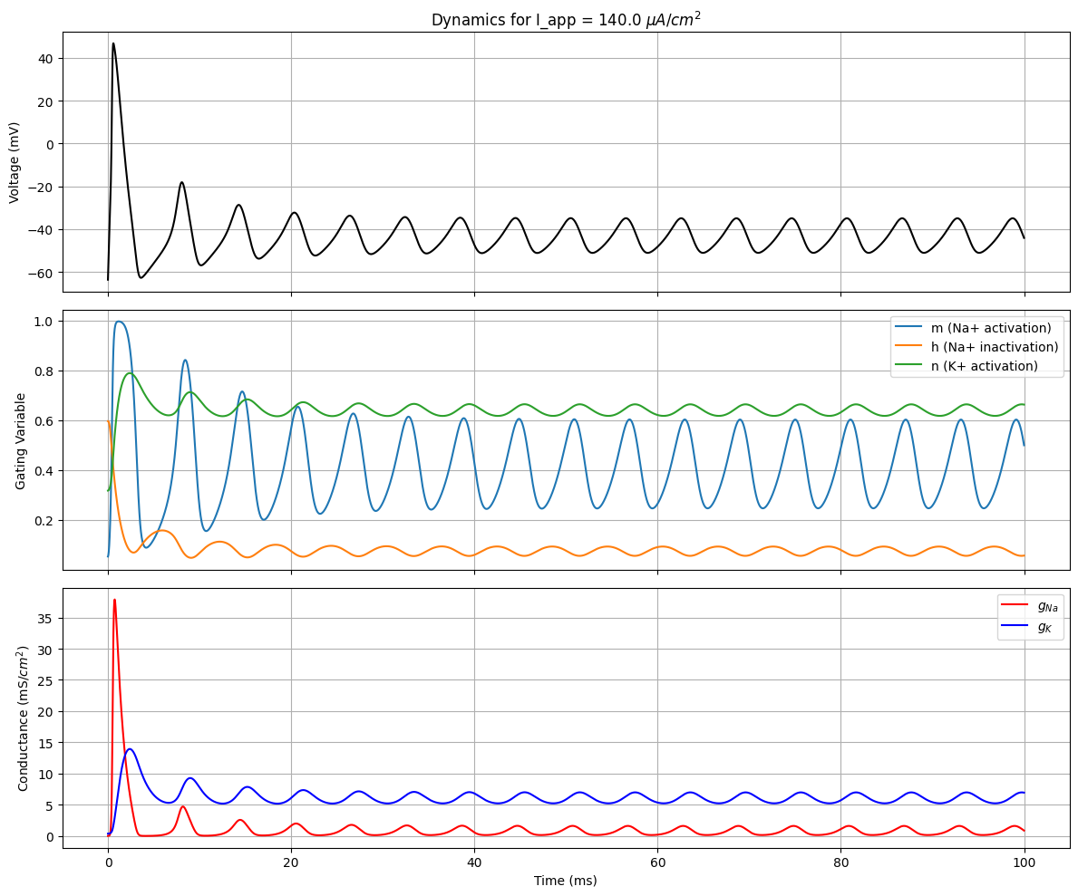

Case 4: Distorted / Depolarization Block
Observation: The neuron fires once (or not at all) and then the membrane potential gets stuck at a highly depolarized level. The extreme input current prevents the sodium channel inactivation gate (h) from recovering, shutting down the spike-generating mechanism.

